**Smart Dustbin Using Arduino Uno**

**Project Overview**

The Smart Dustbin is an IoT-based automated waste management system designed to detect the level of waste in a bin using ultrasonic sensors. The goal is to maintain hygiene, reduce manual monitoring, and enable timely waste disposal. The system is compact, efficient, and ideal for households, schools, and public places.

**Key Features**

* **Automatic Waste Level Detection:** Ultrasonic sensor continuously monitors the fill level.
* **Full Bin Alert:** When the dustbin reaches a predefined capacity, it triggers an alert.
* **Contactless Operation:** Improves hygiene by eliminating the need to touch the lid.
* **Easy Integration:** Can be integrated with IoT dashboards or mobile apps for remote monitoring.
* **Low Power Consumption:** Efficient power usage suitable for battery or solar operation.

**Technologies Used**

* **Arduino Uno** – Microcontroller for controlling the system.
* **Ultrasonic Sensor (HC-SR04)** – Measures the distance to detect the waste level.
* **Jumper Wires & Breadboard** – For circuit connections.
* **Buzzer or LED** *(optional)* – For alert indication.
* **IoT Integration** *(optional)* – Cloud or app connectivity (e.g., using ESP8266 or Bluetooth).

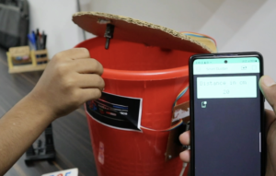

**Outlook of the project**